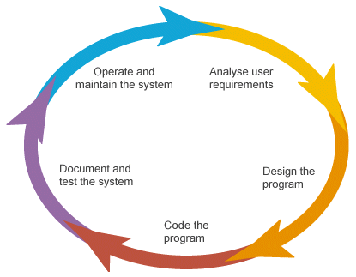Software Development Life Cycle (SDLC) is a process that ensures good software is built. It has 5 phases, starting from the analysis and requirement gathering and end with the implementation. Each phase that are involved in the life cycle has its own process and deliverables that feed into the next phase. Below are the 5 phases that are involved on the SDLC.

There are various Software Development Models or Methodologies (SDM). They are as follows:

1. 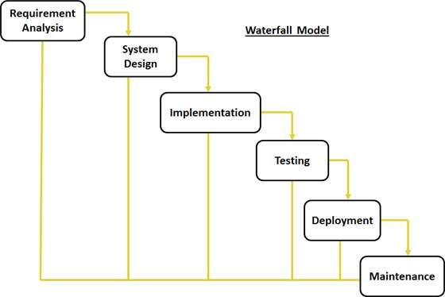Waterfall Model
2. V Model

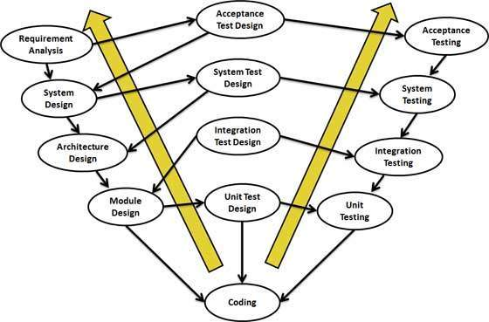

1. Incremental MODEL
2. 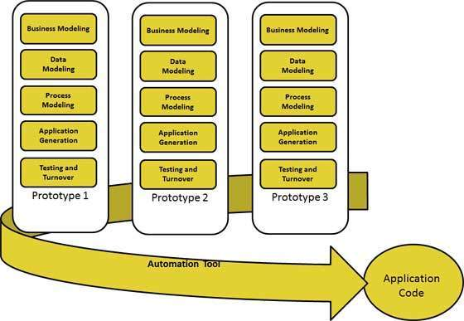RAD Model
3. Agile Model

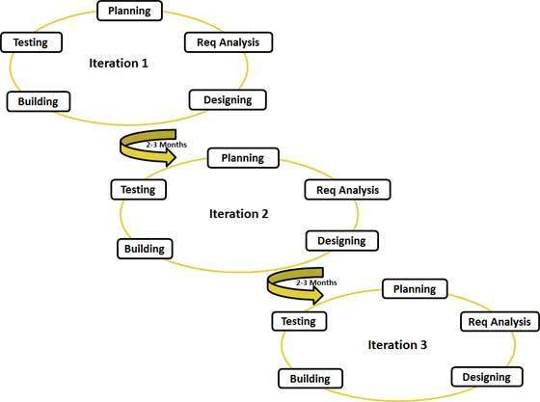

1. Iterative Model

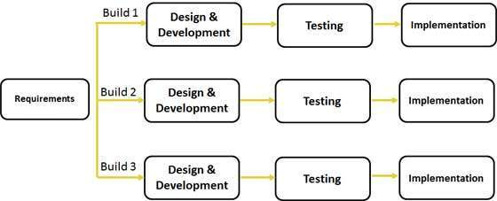

1. Spiral Model

